**App Dynamics – Handson14(Time Slot 12:10PM – 2:10PM)**

**2.1 Business Transactions**

a **business transaction (BT)** represents an end-to-end, cross-tier processing path that fulfils a request for a service provided by the application.

**1. Find out the Top 3 BTs with more errors/min.**

* For this test, if you see there is no error/min.
* BT means, it basically tracks the traffic of the application as a business transaction for a user request.

**2. Find out the BT with highest calls/min.**

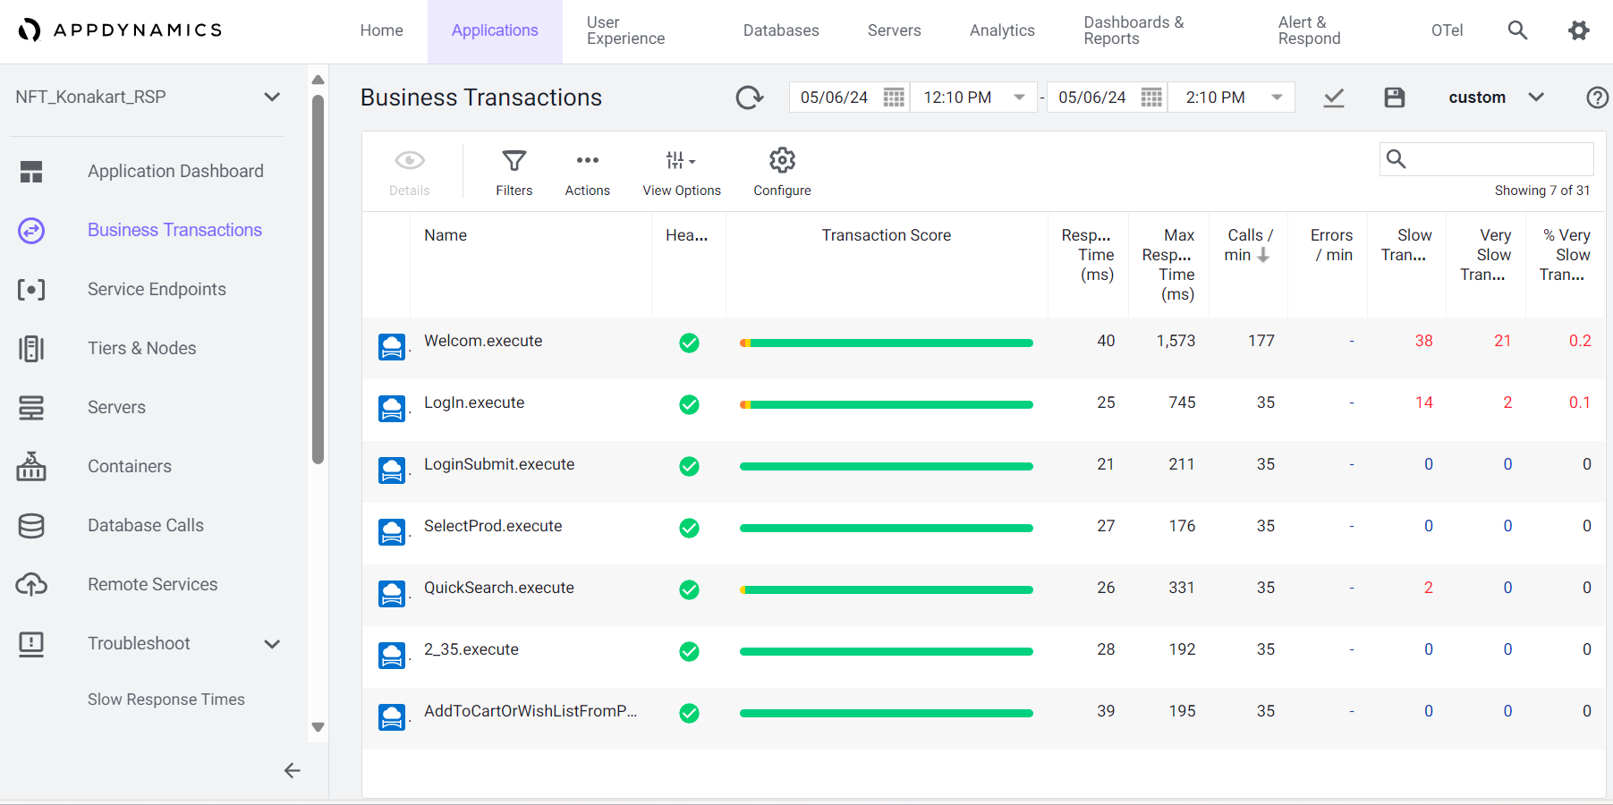

* If you see above snapshot the highest call/min is Welcom.execute- 177, Means it taking more time.
* It calculates the average no of incoming and outgoing calls within a minute.

**3. Find out the health rule violations of BT.**

* There are no Business transactions which has violated the health rule.
* If you see in health column all are in green, if we find any health rule violation then it shows in different colour. Means yellow colour.

**4. Delete Business transaction.**

* To delete business transaction, first you need to select any of the transaction which you want to delete.
* Next click on actions, there you can see Delete Transaction. So, then the transaction will be deleted.

**5. Add Business transaction.**

* Go to BT click sconfigure then click on Add ->next->in summary provide name of BT which you want to add.
* a **business transaction (BT)** represents an end-to-end, cross-tier processing path that fulfils a request for a service provided by the application.

**6. Find the Top 3 Performance degraded Business transaction.**

* The top 3 degraded Business transactions are “LoginSubmit.execute, LogIn.execute, QuickSearch.execute” these are the top 3 degraded transactions.
* Because the response time must be less, if it takes more time then it must be degraded, it is taking more time to respond.

**7. Further drill down in the details of degraded BT.**

* To see drill down first go to Business Transaction
* Business Transaction -> Transaction snapshots -> Select any of the transaction -> Click on details -> Slow calls & Errors -> Select slowest method -> select any of the class -> click on Drill down into call graph.
* To achieve Drill down in the details-First we need to click on Transaction Snapshot in BT.
* Then click on a degraded calls and click on view details. Then we can drill down and expand the details

**2.2 Service Endpoints/Remote Service (NA/Give Screenshots)**

**1. Give the details of Service Endpoints section with screenshots**

* In the above it will show details of service endpoints.
* In the name row you can see all the services endpoints.
* It will show the number of times per min each service endpoint was called.
* Service endpoints provide key performance indicators, metrics, and snapshots.

**2. Find the slow response end points**

* The slow response end points are “Welcom.execute, AddToCart,2_35.execute” because it take more time. So that’s why those are slow response end points.

**3. Find the most used service end points.**

* How can we find most used end points means, which are taking more calls or more transactions. Those are most used end points.
* In this most used end points are “welcome. Execute”. because it has more no of calls.

**4. Find the end points which has more errors.**

* If you see there is no errors in service endpoints.
  1. **Errors and Exceptions**

**1.Give the details of Top 3 Transactions with highest Errors/min.**

* If you see there is no error in the above.

**2. Give the details of User Experience Error for any BT.**

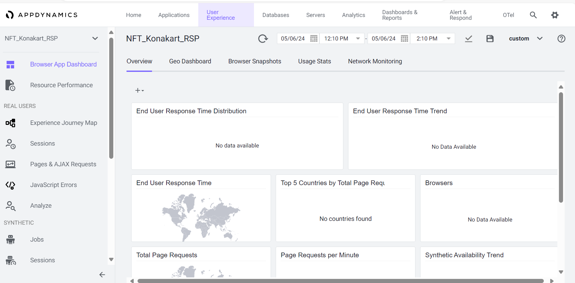

* We see there are no errors for any BT in user experience.

**3.Give the details of Number HTTP Error codes count.**

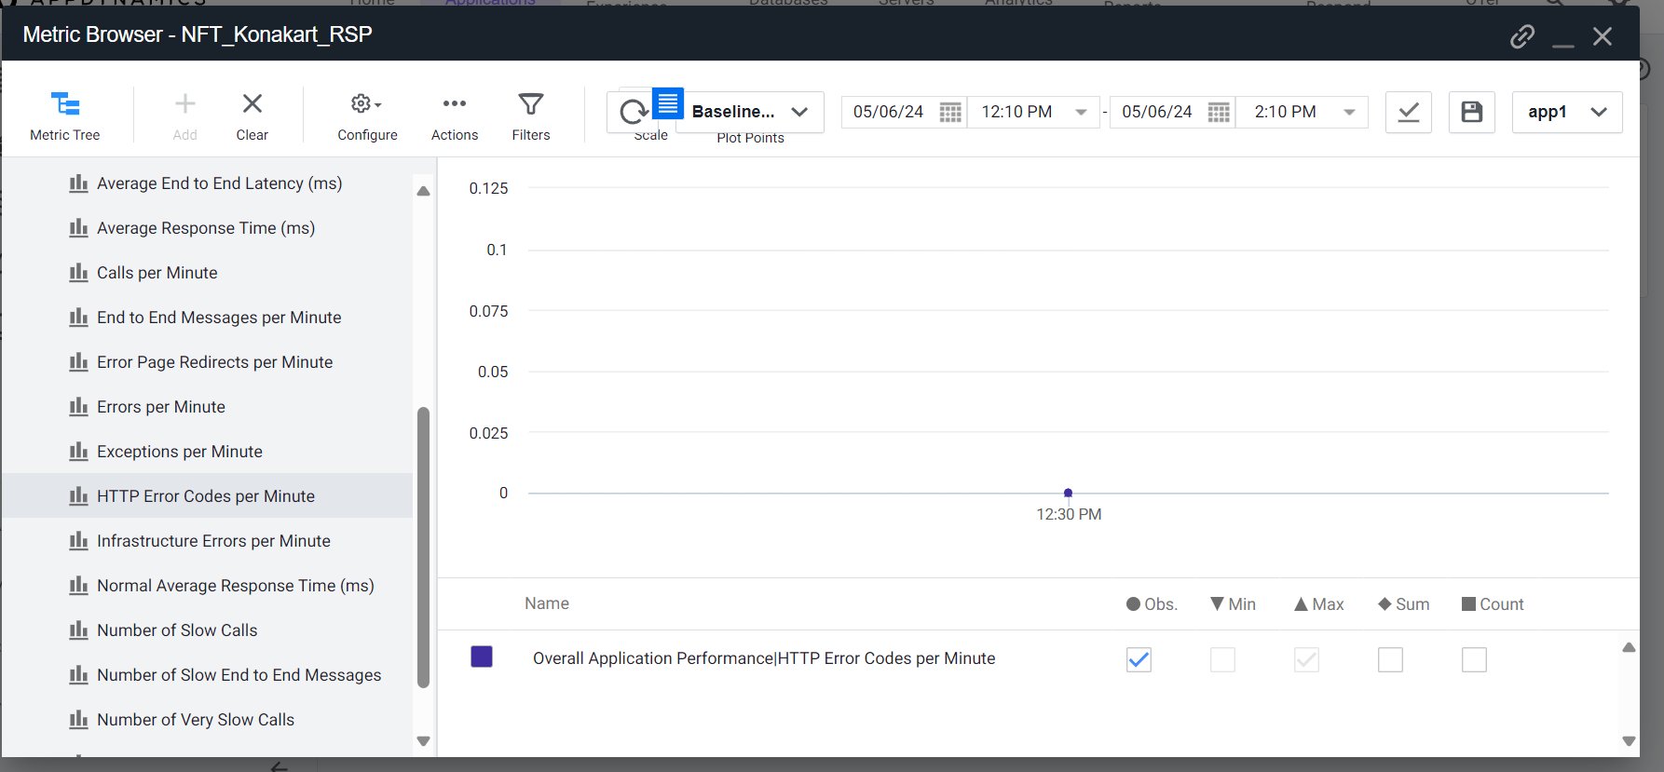

* (There is no HTTP Error Code because of no errors. If we get any error, then we get HTTP Error code.)

**4. Troubleshot based on Exception and call graph**

* We can’t Troubleshot exception and call graph because we didn’t have any baseline results to compare and troubleshot.

**5. Troubleshot based on Slow response time.**

* We can’t Troubleshot Slow response time because we didn’t have any baseline results to compare and troubleshot.